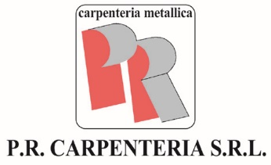

**HEALTH AND SAFETY AT WORK**

**POLICY**

**“Nothing is more important than health and safety of workers, therefore our main priority is to provide a workplace that is safe and healthy”.**

**Pr Carpenteria Srl**, in view of the purposes and the context in which it operates and in view of the strategic aims laid down, has implemented a Health and Safety at work Management system in order to:

* provide workers with safe and healthy working conditions in order to prevent injuries, accidents and work-related illnesses;
* comply with legal requirements and other applicable requirements (e.g. contractual agreements with third parties);
* where possible, eliminate at source the dangers and/or reduce the risks to health and safety at work;
* elevate organization’s safety culture;
* disclose Health and Safety at work Policy to company’s employees, customers and suppliers;

The Direction undertakes to implement all the above and to continually improve the Health and Safety at work Management System through:

* the setting of specific targets for health and safety at work;
* consultation, involvement and participation of the employees and their representative;
* constant communication among various company stakeholders, in order to foster active involvement of the whole company’s organization.

**Pr Carpenteria Srl** undertakes to communicate the present Policy within the organization, to make it available to the parties concerned and, if needed, to periodically review it.